
Solution Architecture

Date | 01 july 2026
Team ID | xxxxxx
Project Name | OptiCrop – AI-Based Crop Recommendation System
Maximum Marks | 5 Marks

Solution Architecture Diagram:

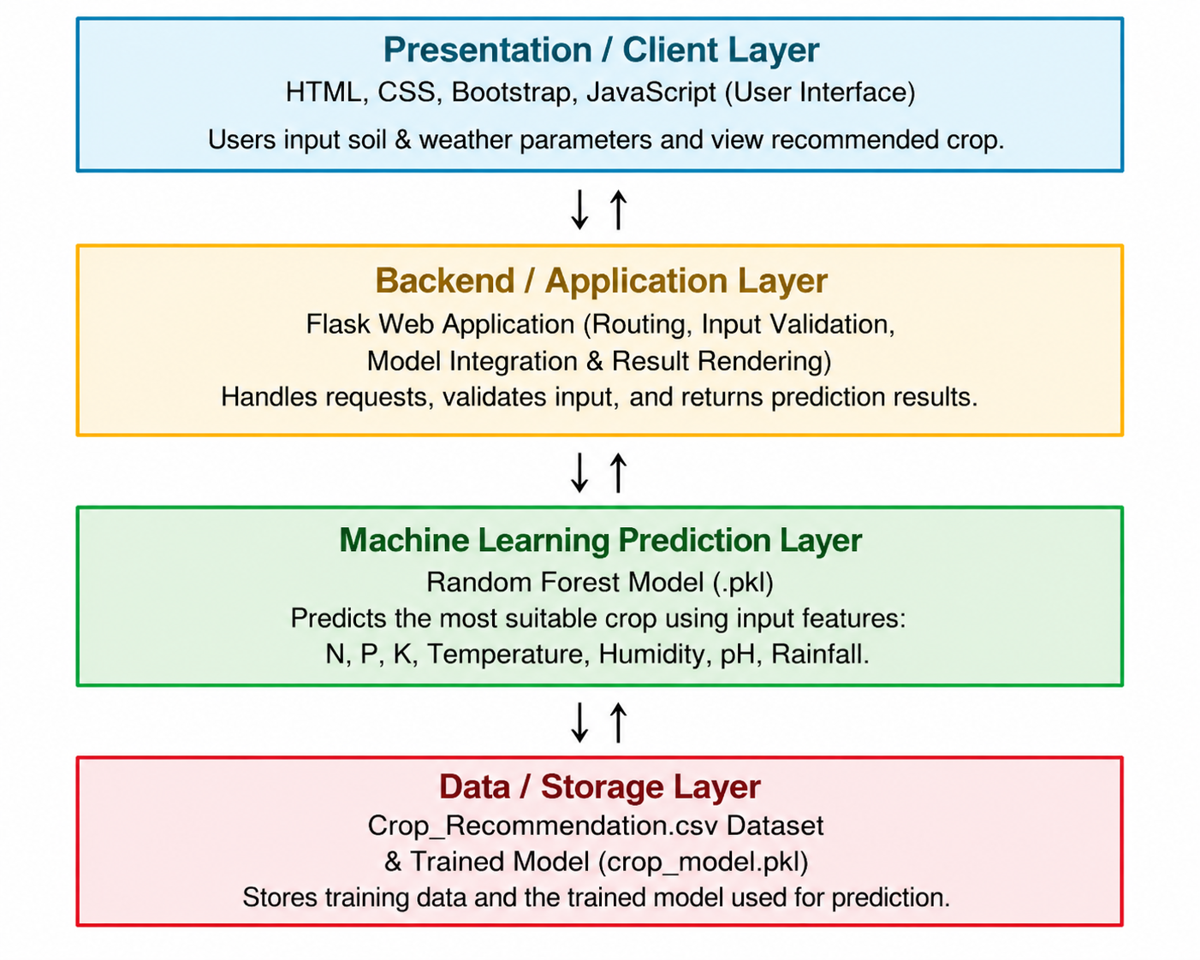


Component Description Table

Component Name | Description / Role in Architecture | Technologies Used
Presentation Layer | Provides a responsive user interface where users enter soil and weather parameters and view the recommended crop. | HTML, CSS, Bootstrap, JavaScript
Flask Backend | Handles user requests, validates input values, loads the trained machine learning model, performs prediction, and returns the recommended crop. | Python, Flask
Machine Learning Model | Analyzes Nitrogen (N), Phosphorus (P), Potassium (K), temperature, humidity, pH, and rainfall to predict the most suitable crop | Scikit-learn, Pickle
Dataset / Storage | Stores the Crop Recommendation dataset used for training and the trained .pkl model used during prediction. | CSV, Pickle

